GRAPHICAL USER INTERFACE

FOR A VOCABULARY GAME

‘Cows and Bulls’

**A MINI PROJECT REPORT**

**Submitted by**

**Madan Kapoor -113214104062**

**Manit Kapoor -113214104069**



VELAMMAL ENGINEERING COLLEGE

CHENNAI-600 066

August, 2015

**VELAMMAL ENGINEERING COLLEGE**

**CHENNAI-600 066**

**BONAFIDE CERTIFICATE**

This is to certify that this mini project titled “Cows and Bulls“was carried out by

**Madan Kapoor -113214104062**

**Manit Kapoor -113214104062**

Of B.E.(CSE) DEPARTMENT, during their II year of study.

**ABSTRACT**

The Objective of this mini project to build a vocabulary skill and word skill increasing

Game Named “Cows and Bulls” .Mind games fascinate a lot of people and It increases our Vocabulary

and logical skills .We have designed a word game in a interactive GUI desktop application .it is built using

the Gtk+ 3 toolkit in the C programming Language. The words are taken from Internet and their source is

referenced in the Application. We hope that the game users will enjoy the experience of the word game

‘Cows and Bulls’.

# Index

1. Introduction

Gtk+

* 1. What is Gtk+?
  2. Gtk Architecture
  3. Gtk Features

1. Game Design
   1. How to play?
   2. Hardware Requirements
   3. Design constraints
   4. Limitations
   5. References
   6. Glossary
2. Implementation and result
   1. GUI implementation
   2. Internal implementation
   3. Snapshots
3. References
4. Sample code

GTK+

**What is GTK+?**

GTK+, or the GIMP Toolkit, is a multi-platform toolkit for creating graphical user interfaces. Offering a complete set of widgets, GTK+ is suitable for projects ranging from small one-off tools to complete application suites. GTK+ is written in C but has been designed from the ground up to support a [wide range of languages](http://www.gtk.org/language-bindings.php), not only C/C++. Using GTK+ from languages such as Perl and Python (especially in combination with the [Glade GUI builder](http://glade.gnome.org/)) provides an effective method of rapid application development.

**Gtk+ Architecture:**

**GTK+** (previously [**GIMP**](https://en.wikipedia.org/wiki/GIMP)**Toolkit**, sometimes incorrectly referred to as the GNOME Toolkit) is a [cross-platform](https://en.wikipedia.org/wiki/Cross-platform)[[3]](https://en.wikipedia.org/wiki/GTK%2B#cite_note-3) [widget toolkit](https://en.wikipedia.org/wiki/Widget_toolkit) for creating [graphical user interfaces](https://en.wikipedia.org/wiki/Graphical_user_interface). It is licensed under the terms of the [LGPL](https://en.wikipedia.org/wiki/GNU_Lesser_General_Public_License), allowing both [free](https://en.wikipedia.org/wiki/Free_software) and [proprietary](https://en.wikipedia.org/wiki/Proprietary_software) software to use it. It is one of the most popular toolkits for the [Wayland](https://en.wikipedia.org/wiki/Wayland_(display_server_protocol)) and [X11](https://en.wikipedia.org/wiki/X_Window_System_core_protocol) [windowing systems](https://en.wikipedia.org/wiki/Windowing_system), along with [Qt](https://en.wikipedia.org/wiki/Qt_(toolkit))

The GTK+ [library](https://en.wikipedia.org/wiki/Library_(computing)) contains a set of [graphical control elements](https://en.wikipedia.org/wiki/Graphical_control_element) (widgets), version 3.13.3 contains 203 active and 37 deprecated widgets.[[*citation needed*](https://en.wikipedia.org/wiki/Wikipedia:Citation_needed)] GTK+ is an [object-oriented](https://en.wikipedia.org/wiki/Object-oriented) [widget toolkit](https://en.wikipedia.org/wiki/Widget_toolkit) written in the [C programming language](https://en.wikipedia.org/wiki/C_(programming_language)); it uses [GObject](https://en.wikipedia.org/wiki/GObject), that is the GLib object system, for the object orientation. While GTK+ is primarily targeted at windowing systems based upon [X11](https://en.wikipedia.org/wiki/X_Window_System_core_protocol) and [Wayland](https://en.wikipedia.org/wiki/Wayland_(display_server_protocol)), it works on other platforms, including [Microsoft Windows](https://en.wikipedia.org/wiki/Microsoft_Windows) (interfaced with the [Windows API](https://en.wikipedia.org/wiki/Windows_API)), and [Mac OS X](https://en.wikipedia.org/wiki/Mac_OS_X)(interfaced with [Quartz](https://en.wikipedia.org/wiki/Quartz_(graphics_layer))). There is also an [HTML5](https://en.wikipedia.org/wiki/HTML5) back-end called *Broadway*.

GTK+ can be configured to change the look of the widgets drawn; this is done using different **display engines**. Several display engines exist which try to emulate the look of the native widgets on the platform in use.

Starting with version 2.8, released in 2005, GTK+ began the transition to using [Cairo](https://en.wikipedia.org/wiki/Cairo_(graphics)) to [render](https://en.wikipedia.org/wiki/Rendering_(computer_graphics)) the majority of its [graphical control elements](https://en.wikipedia.org/wiki/Graphical_control_element_(software)). Since GTK+ version 3.0, all the rendering is done using Cairo.

### GUI designers

There are several [GUI designers](https://en.wikipedia.org/wiki/Graphical_user_interface_builder) for GTK+. The following projects are active as of July 2011:

* [Glade](https://en.wikipedia.org/wiki/Glade_Interface_Designer), supports [GtkBuilder](https://en.wikipedia.org/wiki/GTK%2B" \l "GtkBuilder), which is a GTK+ built-in GUI description format.
* [Gazpacho](https://en.wikipedia.org/w/index.php?title=Gazpacho_(software)&action=edit&redlink=1), GUI builder for the GTK+ toolkit written in Python[[12]](https://en.wikipedia.org/wiki/GTK%2B#cite_note-12)
* Crow Designer, relies on its own GuiXml format and GuiLoader library.[[13]](https://en.wikipedia.org/wiki/GTK%2B#cite_note-13)
* [Stetic](https://en.wikipedia.org/wiki/Stetic), part of [MonoDevelop](https://en.wikipedia.org/wiki/MonoDevelop" \o "MonoDevelop), oriented towards [Gtk#](https://en.wikipedia.org/wiki/Gtk_Sharp" \o "Gtk Sharp).

#### GtkBuilder

Gtk Builder offers you the opportunity to design user interfaces without writing a single line of code. This is possible through describing the interface by a [XML](https://en.wikipedia.org/wiki/Extensible_Markup_Language) file and then loading the XML description at runtime and create the objects automatically, which the Builder class does for you. For the purpose of not needing to write the XML manually the Glade Interface Designer lets you create the user interface in a [WYSIWYG](https://en.wikipedia.org/wiki/What_You_See_Is_What_You_Get) manner.

This method has several advantages:

* Less code needs to be written.
* UI changes can be seen more quickly, so UIs are able to improve.
* Designers without programming skills can create and edit UIs.
* The description of the user interface is independent from the programming language being used.

There is still code required for handling interface changes triggered by the user, but Gtk.Builder allows you to focus on implementing that functionality.[]](https://en.wikipedia.org/wiki/GTK%2B#cite_note-14)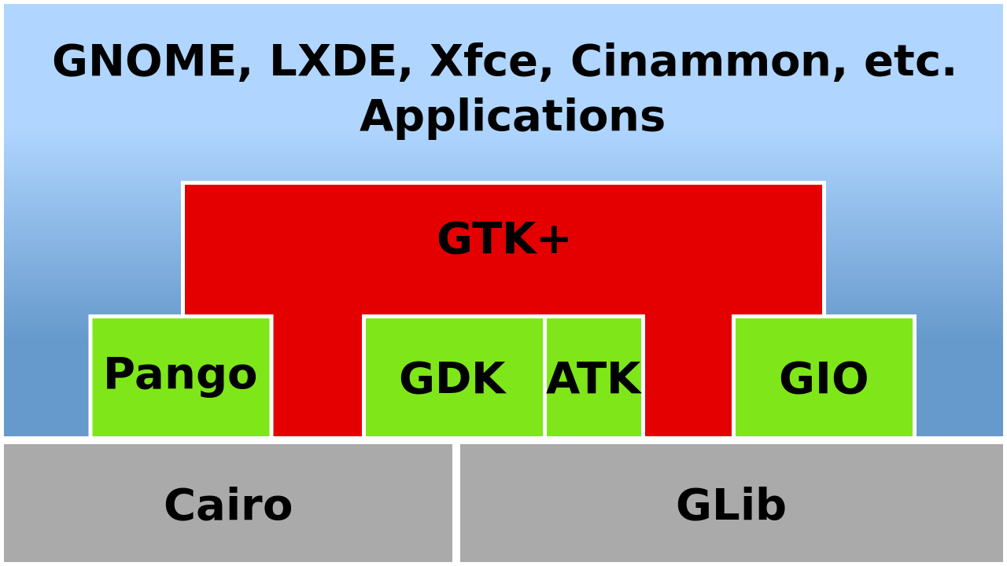

**GTK+ features**

## Stability

GTK+ has been developed for over a decade to be able to deliver the enticing features and superb performance that it brings to your application development. GTK+ is supported by a large community of developers and has core maintainers from companies such as [Red Hat](http://www.redhat.com/) ,[Novell](http://www.novell.com/), [Lanedo](http://www.lanedo.com/gtk+.html),  [Codethink](http://www.codethink.co.uk/), [Endless Mobile](https://endlessm.com/) and [Intel](http://www.intel.com/).

## Language Bindings

GTK+ is available in many other programming languages thanks to the [language bindings](http://www.gtk.org/language-bindings.php)available. This makes GTK+ quite an attractive toolkit for application development.

## Interfaces

GTK+ has a comprehensive collection of core widgets and interfaces for use in your application.

[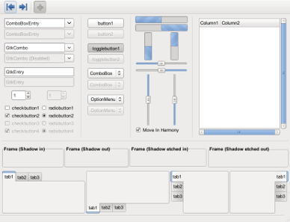](http://www.gtk.org/images/features/twf.png)

* Windows (normal window or dialog, about and assistant dialogs)
* Displays (label, image, progress bar, status bar)
* Buttons and toggles (check buttons, radio buttons, toggle buttons and link buttons)
* Numerical (horizontal or vertical scales and spin buttons) and text data entry (with or without completion)
* Multi-line text editor
* Tree, list and icon grid viewer (with customizable renderers and model/view separation)
* Combo box (with or without an entry)
* Menus (with images, radio buttons and check items)
* Toolbars (with radio buttons, toggle buttons and menu buttons)
* GtkBuilder (creates your user interface from XML)
* Selectors (color selection, file chooser, font selection)
* Layouts (tabulated widget, table widget, expander widget, frames, separators and more)
* Status icon (notification area on Linux, tray icon on Windows)
* Printing widgets
* Recently used documents (menu, dialog and manager)

## Cross Platform

Originally GTK+ was developed for the X Window System but it has grown over the years to include backend support for other well known windowing systems. Today you can use GTK+ on:

* [GNU/Linux and Unix](http://www.gtk.org/download/linux.php)
* [Windows (32-bit)](http://www.gtk.org/download/win32.php) and [64-bit](http://www.gtk.org/download/win64.php)
* [Mac OS X](http://www.gtk.org/download/macos.php)

## Accommodating

GTK+ caters for a number features that today's developers are looking for in a toolkit including:

* Native look and feel
* Theme support
* Thread safety
* Object oriented approach
* Internationalization
* Localization
* Accessibility
* Bidirectional text support (LTR/RTL, Left To Right/Right To Left)
* UTF8 support
* Documentation

## Foundations

GTK+ is built on top of GLib. GLib provides the fundamental algorithmic language constructs commonly duplicated in applications. This library has features such as: (this list is not a comprehensive list)

* Object and type system
* Main loop
* Dynamic loading of modules (i.e. plug-ins)
* Thread support
* Timer support
* Memory allocator
* Threaded Queues (synchronous and asynchronous)
* Lists (singly linked, doubly linked, double ended)
* Hash tables
* Arrays
* Trees (N-ary and binary balanced)
* String utilities and charset handling
* Lexical scanner and XML parser
* Base64 (encoding & decoding)

## Mobile

The GMAE (GNOME Mobile & Embedded) initiative has advanced the use, development and commercialization of GNOME components as a mobile and embedded user experience platform. It has brought together industry leaders, expert consultants, key developers and the community and industry organizations they represent. As a direct result of this, GTK+ has features pertaining to mobile and embedded platform requirements.

GTK+ has been involved in a number of embedded initiatives over the past few years including the development of:

* Nokia [770](http://europe.nokia.com/A4145104) / [N800](http://web.nseries.com/products/#l=products,n800) / [N810](http://web.nseries.com/products/#l=products,n810) / [N900](http://maemo.nokia.com/n900/)
* [One Laptop Per Child Project](http://www.laptop.org/)
* [OpenMoko](http://www.openmoko.com/)

Game Design:

**COWS AND BULLS WORD GAME:**

 **Cows and Bulls i**s an old code breaking mind or paper and pencil game. It is a game with numbers or words that may date back a century or more. This game helps us to increase our thinking capabilities and glossary. This game is developed for windows using GIMP tool kit using C language. GUI is also improved using CSS. Words are taken from [www.morewords.com](http://www.morewords.com).

The Game exists in word and number version. This application is a word game.

The first official massively multiplayer (MMO) version of this game was first made available for Android devices under name WORD - Multiplayer Word Game. Few versions of this type game are available in Computer & Mobile devices.



